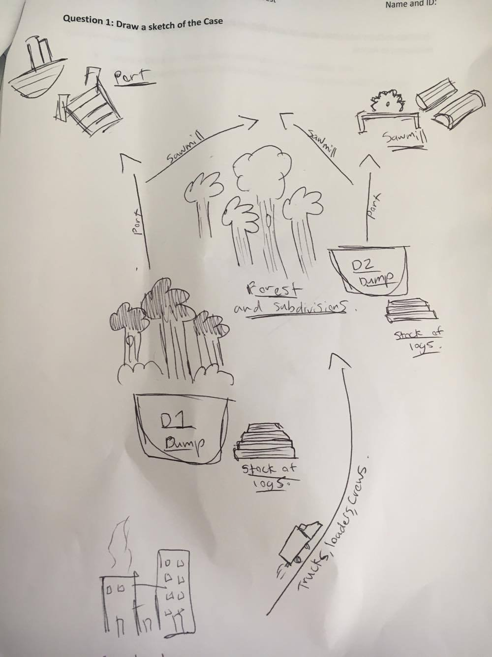

Note – Will change this to a storyboard form with more annotations for the test. Need to practice more before Monday.

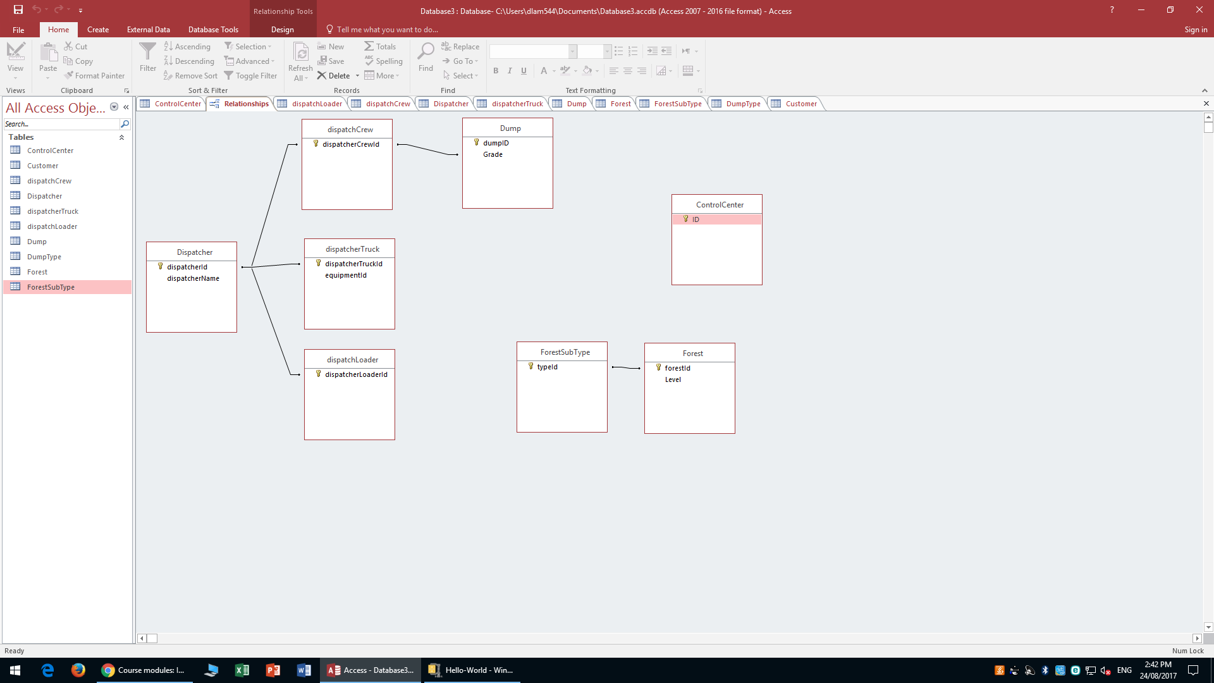

This is really difficult I need to practice more.. on how to do the erd data..

3. In order to select a truck or other object and display it’s properties we must

In order to show a dashboard/menu to the Hololens user that moves with them the user must first open the menu by doing a swipe up kinda of motion. Then in order to get the dashboard/menu to tag along with us we have to gaze at the menu and do a tap.

https://developer.microsoft.com/en-us/windows/mixed-reality/design

4.

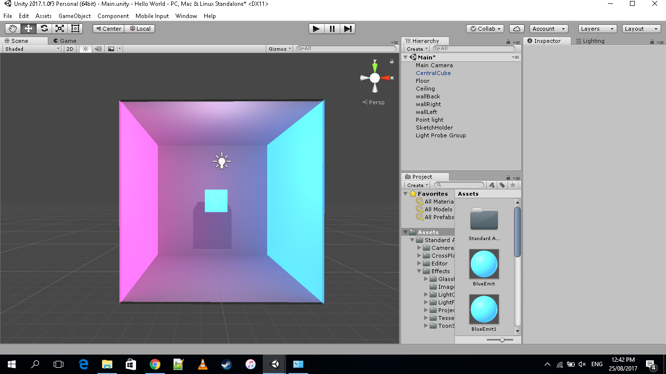

5. – (need to revise this)

6. - I failed to do this.. have to learn how to code it properly but I assuume it is using the rand()

7.